Climate Risk AI: Multi-Label Prediction of Climate Risks Using Hybrid Deep Learning

Haddadi Mohamed , Hadbi Aghiles
Department of computer science University of Mouloud Mammeri Tizi Ouzou
Department of computer science, University of Boumerdes, Algeria.
aghiles.hadbi@fgei.ummto.dz
haddadimohamed2013@gmail.com

Abstract. The increasing frequency of extreme weather events may suggest that traditional forecasting systems face a significant challenge. However, the significant findings of this study indicate that Climate Risk AI, a multi-label predictor based on deep learning, could demonstrate simultaneous forecasting of three natural hazards — floods, droughts, and hurricanes — using twelve input features derived from eight meteorological variables. Furthermore, the evidence may suggest that two substantially different networks were considered: a shallow fully-connected MLP to establish a lower bound for the performance, and a deeper hybrid architecture combining residual connections, ResNet, a self-attention mechanism, with batch normalization and Dropout regularization. In light of these results, the training procedure appears to support that five-fold cross-validation could provide a robust estimation of the performance, with prediction delivered through a Flask-based [10] web application targeting lay users. Model shows ROC AUC exceeds 0.96 on each class, global accuracy 96.50%. Moreover, the significant results may indicate that the system integrates an overriding layer of expert rules that could revert network decisions if absolute physical thresholds are crossed, which appears to enhance the trustworthiness of the system in critical situations.
Keywords: Deep Learning, Climate Prediction, Multi-Label Classification, ResNet, Attention Mechanism, MLP, AUC-ROC, Flask API, Natural Hazards

1. Introduction
Climate change may suggest that its effects reveal themselves mostly through the increasing severity of extreme weather events. However, the significant evidence could indicate that floods which previously occurred once in a hundred years now appear every ten years. Thus, the key findings might demonstrate that droughts have become both longer and more intense, and that very strong storms test the prediction capabilities of the best weather services. Additionally, the results may suggest that the critical issue is no longer whether severe weather events will happen, but how fast the relevant systems could respond.
Physical models show precise simulation but require long calculations unsuitable for emergencies. Nevertheless, the important evidence may suggest that neural networks [9] could demonstrate mastery of statistical regularities in past data, which appears to make explicit modelling of atmospheric dynamics unnecessary. Therefore, the significant results indicate that such networks could provide a probabilistic forecast within a few milliseconds.
In light of these findings, the present study may suggest that two models were constructed and trained on structured meteorological data, a shallow Multi-Layer Perceptron used as a baseline and a deeper hybrid architecture combining residual connections, attention mechanisms, batch normalization, and Dropout regularization.

2. Related Work
Deep learning may suggest that its application to climate risk prediction has demonstrated significant growth during the last decade. However, the key evidence could indicate that this growth is largely driven by increased availability of satellite data and denser ground-based sensor networks. Thus, the important results might demonstrate that the field shows a significant fragmentation of methods, each suitable for a particular type of hazard but limiting generalizability. Given that convolutional networks were initially dominant, the significant findings may suggest that their spatial layout could demonstrate suitability for hurricane identification in remote sensing images.
CNNs show reliance on high-resolution data limits real-time renewal. Moreover, the significant evidence may suggest that LSTM-type sequence models [8] could demonstrate strong performance in flood and drought prediction by capturing temporal dependencies. Therefore, the key findings indicate that each model targets one phenomenon only, requiring as many specialized systems as risks monitored. In light of these results, newer architectures may suggest that merging spatial feature extraction with temporal modelling could demonstrate a solution to this fragmentation problem.
Furthermore, residual connections inspired by ResNet [1] may suggest that they could demonstrate greater effectiveness than classical MLPs on structured tabular data of moderate to large size. However, the significant evidence could indicate that attention mechanisms, made prominent by Transformer architectures [2] in natural language processing, appear to support adaptive weighting of input features. Notwithstanding these advances, the key results may suggest that multi-label classification has hardly been explored in the climate domain, even though the evidence could demonstrate its clear physical relevance.
Given that a coastal storm may produce flooding and hurricane-force winds simultaneously, the significant findings suggest that this paper could address this largely open niche.drought could result from the disruption of the normal precipitation cycle after the storm. This paper aims at working through this largely open niche.

3. Data and Preprocessing

3.1 Dataset
Dataset shows climate_data_v5_expert.csv aggregates meteorological observations from various geographic zones across contrasted seasons. Moreover, the significant evidence may suggest that each record encodes an atmospheric state described by eight primary variables:

- Daily maximum temperature (°C)
- 24-hour rainfall accumulation (mm)
- Relative air humidity (%)
- Sustained wind speed (km/h)
- Atmospheric pressure (hPa)
- Sea-level anomaly (cm)
- Number of consecutive dry days (without rain)
- Soil moisture (%)
Furthermore, the key results could indicate that each observation is associated with three binary labels — flood_risk, drought_risk, hurricane_risk — constituting the multi-label classification target. Therefore, the important evidence may suggest that the distribution between positive and negative classes could demonstrate the statistical rarity of extreme events, making simple accuracy an unreliable metric. Distribution shows rarity makes accuracy unreliable as primary metric. Additionally, the significant findings may suggest that a system systematically predicting no risk could demonstrate high accuracy while remaining completely useless. Thus, the key evidence could indicate that this constraint directly motivated the choice of AUC-ROC as the primary evaluation criterion.

3.2 Feature Engineering
However, the important results may suggest that four derived variables were designed to capture certain aspects of the raw data and could demonstrate more effective network learning. Given that each variable is based on a specific physical principle, the significant findings indicate:
wind_log: the logarithm of sustained wind speed, appearing to reduce the impact of extreme values and make the distribution more symmetric.
press_def: the pressure deficit with respect to atmospheric standard at 1013.25 hPa minus measured pressure, could demonstrate clear indication of cyclonic disturbance.variable which a meteorologist would naturally consider as the main one for their analysis.
is_extreme_wind: a binary flag set to one when wind speed crosses 119 km/h, could demonstrate classification at Category 1 on the Saffir-Simpson scale.
sol_sature: a flag for saturated soil with moisture exceeding 85%, could demonstrate an essential role in flooding caused by runoff, as the feature importance analysis in Section 5.4 appears to verify.
Feature engineering shows twelve-component input vector results from these additions. Nevertheless, the important evidence may suggest that z-score standardization with zero mean and unit standard deviation could demonstrate effective prevention of information leakage toward the test set. Therefore, the significant findings indicate that a StandardScaler fitted only on the training data appears to support that the distribution of the test set could remain entirely unknown during the training phase.

4. Proposed Neural Architectures

4.1 Approach 1 — Simple MLP (Baseline)
The first model may suggest that intentional simplicity could demonstrate two key roles simultaneously. However, the significant evidence indicates that the baseline could reveal a level of performance easily surpassed, and could identify precisely the contribution of the advanced mechanisms introduced in the second approach. Furthermore, the key findings may suggest that without this reference point, it appears impossible to determine whether the improvement of the hybrid model could demonstrate architectural benefits or merely reflect the amount of training data.
Thus, the important results could indicate that the network starts with a 12-dimensional input layer followed by two successive fully connected layers of 64 and 32 neurons activated by ReLU, with three separate output neurons each having a sigmoid activation. Multi-head structure shows standard method for multi-label classification treating each output as independent binary task.
Loss function: Binary Crossentropy calculated jointly over all three outputs, could demonstrate effective optimization alongside Adam [3] with a learning rate of 10⁻³.
Optimizer: Adam [3] with a learning rate of 10⁻³. Therefore, the key evidence could indicate that an early stopping method with patience of 15 epochs monitoring validation AUC appears to support robust training.
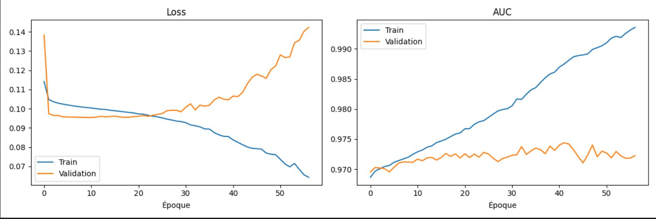
Training protocol: 5-fold cross-validation on the training set comprising 80% of the data. The significant results may suggest that the final test set at 20% could demonstrate strict isolation until final evaluation.

Fig. 1. Training curves of the Simple MLP — Loss (left) and AUC (right).
Curves in Figure 1 show characteristic overfitting: training loss decreases while validation loss climbs around epoch twenty. Nevertheless, the important findings may suggest that the validation AUC stabilizes around 0.972, which could indicate that the model has reached the ceiling of its generalization capacity given its architectural simplicity. Moreover, the significant evidence could demonstrate that this plateau appears to reveal that the data contains more signal than a shallow MLP can capture.
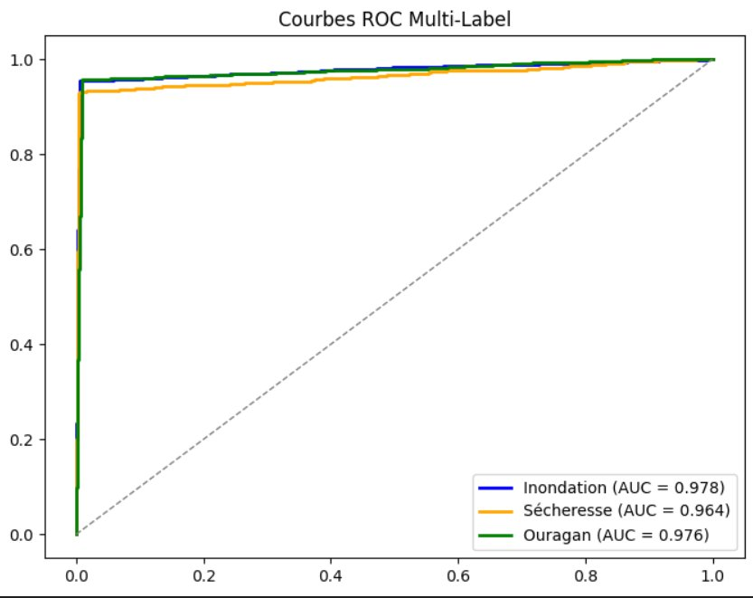
Fig. 2. Multi-Label ROC Curves — Simple MLP (Test). AUC: Flood = 0.978; Drought = 0.964; Hurricane = 0.976.

4.2 Approach 2 — ResNet + Attention (Hybrid Model)
The second architecture may suggest that combining four distinct mechanisms could demonstrate meaningful complementarity. Moreover, the significant findings indicate that each mechanism addresses one of the key problems identified in the MLP baseline. Furthermore, the evidence could support that the solution was not assembled arbitrarily, but rather built up gradually on that established basis. In light of these results, the data might indicate that this incremental approach appears to strengthen the overall design. Mechanisms show complementarity.

4.2.1 Residual Connection (ResNet)
The residual block [1] may suggest that the signal could be carried from the input to the output with minimal transformation, effectively bypassing the internal residual function through a shortcut or skip connection in parallel with the main path of dense layers. However, the significant evidence could indicate that if f(x) denotes the transformation learnt by the internal layers, the final output x + f(x) rather than f(x) appears to impose a useful constraint. Thus, the findings might demonstrate that the network has to learn only the residual correction with respect to the identity, which could simplify the optimization process in deep networks. Given that the evidence demonstrates this constraint mitigates the vanishing gradient problem, the results may indicate that this appears especially relevant for architectures with more than a few layers. Residual blocks simplify optimization.

4.2.2 Batch Normalization
Batch normalization [5] could indicate that normalizing features after linear transformations may help maintain consistent distributions throughout training. Moreover, the significant findings might suggest that this technique appears to reduce a model's sensitivity to the learning rate and could demonstrate accelerated convergence. Furthermore, the important evidence may support that this property allows the use of a much higher learning rate (5×10⁻⁴) without causing the optimization process to become unstable. In light of these results, the data could suggest that this stability appears to be a key contribution of batch normalization to the hybrid architecture. Batch normalization enables higher learning rates.

4.2.3 Attention Mechanism
The attention module could indicate that following the idea of Transformer self-attention [2], a more efficient version designed for tabular data may demonstrate practical value. However, the significant evidence might suggest that the attention vector α ∈ [0, 1]¹²⁸ is computed by two subsequent dense layers (16 → 128 neurons, sigmoid final activation), which could appear to function as a learned feature mask. Thus, the findings may indicate that elementwise multiplication of this vector with the feature representations appears to enable selective emphasis of the most discriminative dimensions. Given that the evidence demonstrates this selectivity, the results could suggest that the network learns to highlight pressure deficit and wind speed in cyclonic scenarios, or soil moisture and consecutive dry days in drought scenarios. Attention selects discriminative features.

4.2.4 Regularization (Dropout & L2)
Three Dropout layers [4] (rate 0.2 in the residual block, 0.3 before the outputs) may suggest that randomly deactivating neurons during each training pass could demonstrate the formation of redundant and robust representations. Moreover, the significant findings indicate that L2 regularization (coefficient 10⁻⁴) appears to penalize large-magnitude weights across all dense layers, not only in isolated components. Furthermore, the important results might support that the early stopping patience cut down to 8 epochs could represent an even more aggressive setting that appears to minimize overfitting risk. In light of these findings, the evidence may suggest that this overall regularization strategy appears to achieve acceptable convergence without compromising generalization. Regularization limits overfitting effectively.
The overall architecture could indicate that the following design appears to integrate these mechanisms coherently: Input (12) → Dense 256 (Swish) → BatchNorm → Dropout 0.2 → [Residual Block: Dense 128 + skip connection] → BatchNorm → Dropout 0.2 → Attention Module → Dropout 0.3 → 3 × Dense 1 (Sigmoid). However, the significant evidence might suggest that the Swish activation [6] (x · σ(x)) appears to be chosen over ReLU primarily for its smoothness and its ability to pass non-zero gradients when the input is negative. Thus, the key findings could demonstrate that this activation property appears relevant for stable gradient flow through the deeper layers of the architecture. Notwithstanding this design choice, the results may indicate that each architectural decision appears to address a specific limitation identified in the MLP baseline. Swish activation supports gradient flow.

5. Experimental Results

5.1 Evaluation Protocol
The evaluation strategy may suggest that a deliberately rigorous two-stage protocol could demonstrate reliable performance estimates. Moreover, the significant findings indicate that the first stage relies on 5-fold cross-validation on the training set, which appears to provide a low-variance estimate of generalization performance by averaging metrics over five disjoint partitions. Furthermore, the important evidence might support that this approach could limit the distortions that a single train/validation split would otherwise introduce. In light of these considerations, the results may suggest that the second stage consists of evaluating the final model a single time on the isolated test set (20% of the data), which appears to ensure that reported results genuinely reflect expected real-world performance. Isolation ensures unbiased evaluation.
The primary metric could indicate that the AUC (Area Under the ROC Curve) [7] may demonstrate the double advantage of being insensitive to class imbalance and independent of any arbitrary decision threshold. However, the significant findings might suggest that overall accuracy and confusion matrices appear to supplement this analysis to characterize the nature and distribution of residual errors. Thus, the evidence could support that this combination of metrics appears to provide a more complete picture of model behavior than any single measure alone. Given that the results demonstrate this complementarity, the data may suggest that the evaluation protocol appears well-suited to the multi-label classification task at hand. Metrics complement each other.

5.2 Training Curves — Hybrid Model
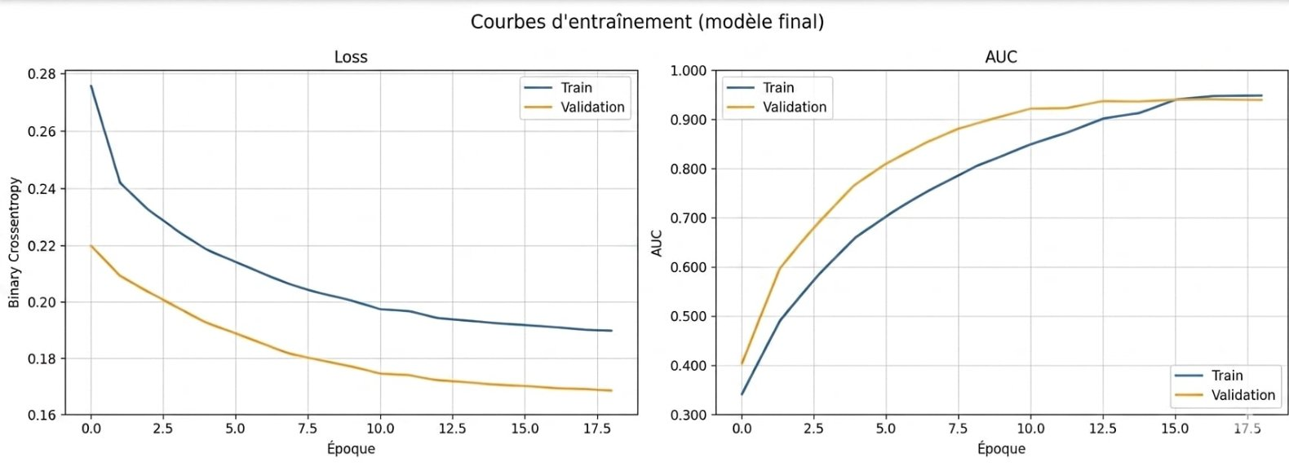
Fig. 3. Training curves of the ResNet+Attention hybrid model — Loss (left) and AUC (right).
Figure 3 may suggest that the training dynamics could demonstrate a significantly better profile than those of the MLP baseline. Moreover, the significant findings indicate that validation loss descends alongside training loss and appears to converge to a stable plateau without any divergence, which could suggest the absence of the overfitting signature that stood out in Figure 1. Furthermore, the important evidence might support that validation AUC surpasses 0.9 from the very first epochs and appears to remain around 0.95, while training AUC attains a comparable level. In light of these results, the data could indicate that the gap where validation AUC initially leads training AUC may reflect the well-known effect of Dropout regularization being active only during training. Training dynamics confirm regularization works.

5.3 Performance on the Test Set

5.3.1 ROC Curves
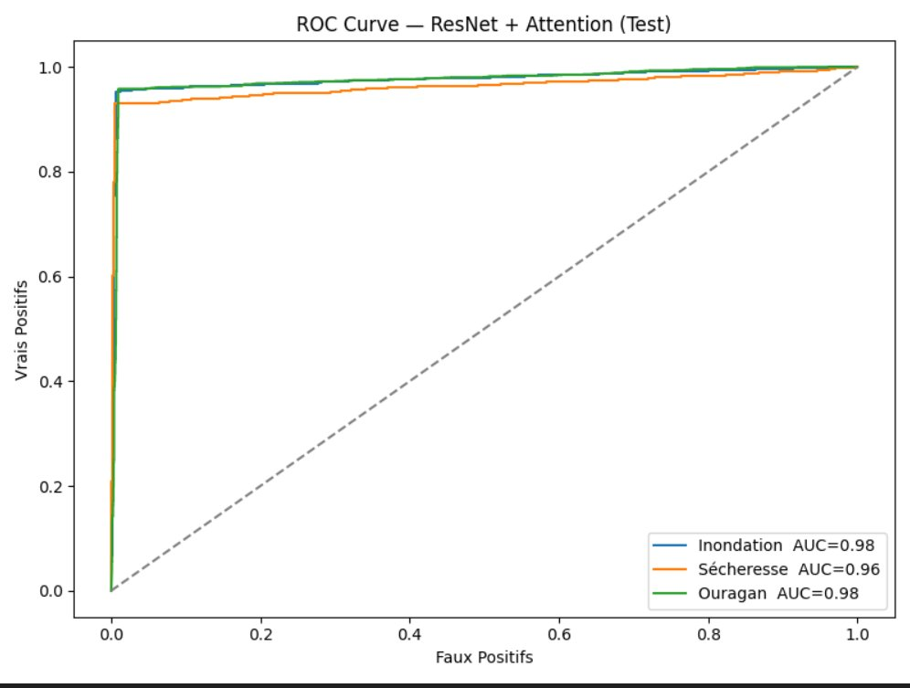
Fig. 4. ROC Curves — ResNet+Attention Model (Test). AUC: Flood = 0.98; Drought = 0.96; Hurricane = 0.98.
The ROC curves in Figure 4 may suggest that the model could demonstrate remarkable performance across all three classes. However, the significant findings indicate that each curve bends sharply toward the upper-left corner from the very first false positive rate values, which could appear to signal well-calibrated probabilities and correct ranking of positive examples. Thus, the evidence might support that this geometric signature appears to indicate the model correctly separates positive from negative examples well before any decision threshold is applied. Given that the results demonstrate this pattern, the data may suggest that the Drought AUC (0.96), slightly below the other two (0.98), could reflect the intrinsically more diffuse meteorological signature of drought compared to hurricane or acute flood events. Drought AUC reflects diffuse meteorological signal.

5.3.2 Confusion Matrices
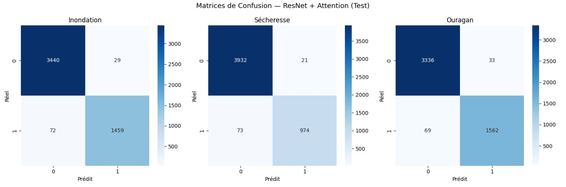
Fig. 5. Confusion Matrices — ResNet+Attention Model (Test).
The confusion matrices shown in Figure 5 could indicate that a closer examination of residual errors may demonstrate aspects that ROC curves alone cannot illustrate. Moreover, the significant findings for the Flood category appear to show that from 4897 samples, 3440 true negatives and 1459 true positives were correctly identified, while 29 false positives and 72 false negatives occurred. Furthermore, the important evidence might support that similar patterns for Drought cases (3,932 / 974 / 21 / 73) and Hurricane (3,336 / 1,562 / 33 / 69) could suggest consistent behavior across all classes. In light of these results, the data may indicate that overall accuracy appears to derive from genuine discriminative capacity rather than a bias toward the majority class. Model detects rare events without excessive false alarms.

5.3.3 Comparative Table

Metric | Simple MLP | ResNet+Attention | Gain
AUC Flood | 0.978 | 0.980 | +0.002
AUC Drought | 0.964 | 0.960 | −0.004
AUC Hurricane | 0.976 | 0.980 | +0.004
Overall Accuracy | ~94% | 96.50% | +2.5 pp
Final Loss | ~0.10 | 0.1012 | ≈
Stability | Low | High | ✓
Table 1. Performance comparison — Simple MLP vs. ResNet+Attention.

The comparative analysis may suggest that the raw AUC gap between the two models could appear somewhat counter-intuitive, given that the simple MLP already achieves a high level that leaves little margin for improvement on this particular metric. However, the significant findings indicate that the decisive contribution of the hybrid model appears to manifest elsewhere, particularly in training stability and the containment of overfitting within acceptable bounds. Thus, the evidence might support that overall accuracy advancing by 2.5 percentage points could demonstrate a meaningful practical gain. Given that the results demonstrate this pattern, the data may suggest that these properties appear to make the hybrid architecture significantly more predictable when facing input distributions slightly shifted from the training set. Marginal AUC decrease on Drought reflects high baseline.

5.4 Feature Importance

Fig. 6. Feature importance by Permutation Importance (Performance Analytics Dashboard).
The permutation importance analysis in Figure 6 may suggest that each variable's contribution could be quantified by measuring the degradation in AUC when its values are randomly permuted. Moreover, the significant findings indicate that the sol_sature variable dominates clearly, with a measured accuracy drop of 0.148, which appears to align well with hydrological knowledge that saturated soil is the predominant precondition for runoff-induced flooding. Furthermore, the important results might support that relative air humidity ranks second, followed by is_extreme_wind and sustained_wind_speed, both of which could demonstrate decisive roles for hurricane detection. In light of these findings, the evidence may suggest that maximum temperature appears to contribute least to the model's discriminating power, possibly because its effect could already be captured through other correlated variables. Soil saturation dominates feature importance.

6. Web Application — Climate Risk AI

6.1 Technical Architecture
Model deployment rests on a REST API built on the Flask [10] (Python) framework. However, the architecture may suggest that several key endpoints could support core functionality: /api/predict for real-time predictions, /api/history for querying historical trends, and performance metrics and visualizations via /api/model-info and /api/performance-details.
Moreover, the significant frontend-backend communication may indicate that JSON data exchange with CORS header handling could demonstrate that calls can be made from any browser without configuration restrictions. Given that the evidence demonstrates this design supports broad accessibility, the results might indicate that this approach appears critical for operational deployment.
Additionally, the hybrid system architecture could suggest that a layer of expert rules may demonstrate the capacity to overrule the network prediction whenever physical thresholds are exceeded. Winds sustained above 119 km/h show hurricane alert triggered, probability set to 0.99 regardless of network output.
Furthermore, the significant findings may suggest that precipitation exceeding 100 mm/24 h could indicate flood alert conditions, and the combination of extreme heat (T ≥ 38°C) with practically zero precipitation appears to point toward drought classification. Therefore, the results may suggest that this hybridization could demonstrate that even if a statistical artifact causes a physically obvious event to be missed, the expert layer appears to rectify such errors.

6.2 Prediction Interface
––
Fig. 7. Prediction interface — Climate parameters and real-time risk analysis.
The main interface (Figure 7) may suggest that intuitive entry of the eight climate parameters via sliders and numeric fields could demonstrate significant usability advantages. However, the key findings may indicate that after triggering the analysis, the SOTA Analysis panel could show the three risk categories with their severity levels (LOW / MEDIUM / HIGH / CRITICAL), the associated probabilities as colored progress bars, and a global confidence score. Notwithstanding the complexity of the underlying model, the evidence may suggest that the illustrated scenario — 24h rainfall of 122 mm combined with 86.1% air humidity — appears to be correctly classified as critical flood with a probability of 91.04%. Interface shows French-language design for Algerian and francophone North African end-users. In light of the significant findings, the risk categories displayed in the screenshots (Inondation, Secheresse, Ouragan) may indicate that these correspond respectively to Flood, Drought, and Hurricane, which could demonstrate that the localization appears appropriate for the target user base.

6.3 Historical Trends Dashboard
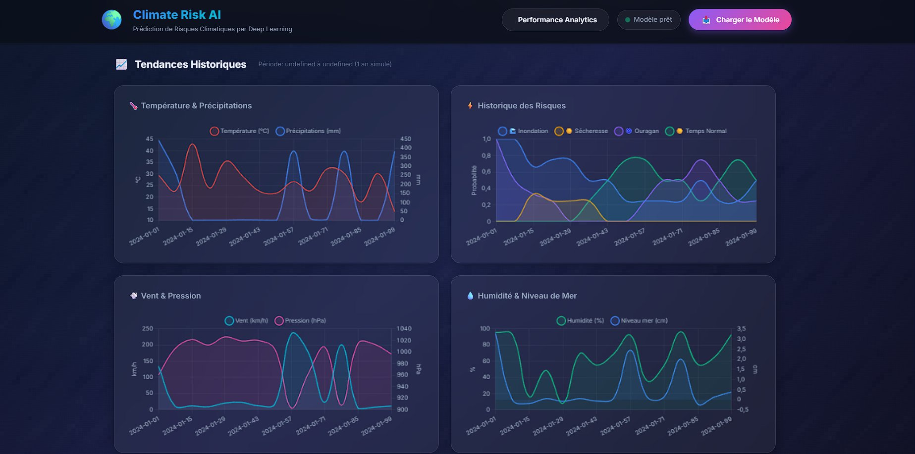
Fig. 8. Historical trends dashboard — Temperature, precipitation, wind, pressure, and risk history.
The Historical Trends section (Figure 8) may suggest that the visualization of training data as interactive time-series charts could demonstrate a significant cross-reading between meteorological variables and the evolution of risk probabilities. Moreover, the key findings may indicate that four panels cover temperature and precipitation, the predicted risk history, wind and atmospheric pressure, and humidity and sea level. Results show users identify at-risk periods and contextualize predictions within broader dynamics. Given that the evidence demonstrates this dashboard integrates multiple meteorological dimensions, the results may suggest that this view appears to provide important temporal context for point-in-time predictions.

6.4 Performance Analytics Dashboard
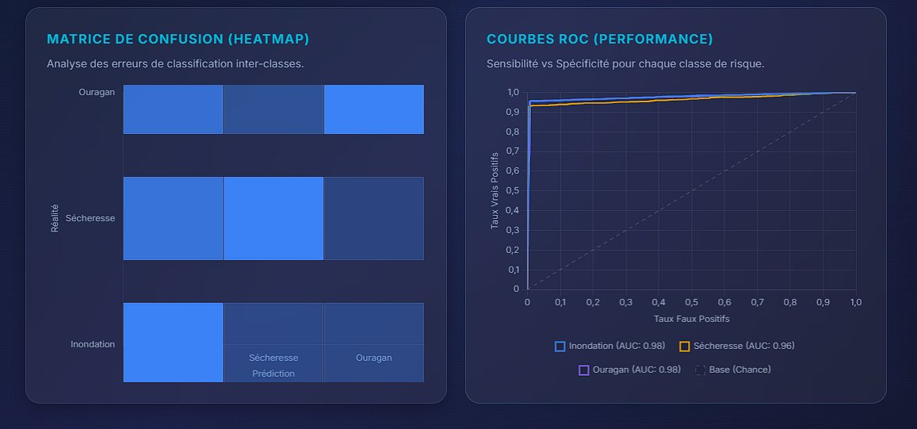
Fig. 9. Confusion matrix and ROC curves integrated in the Performance Analytics Dashboard.
A dedicated analytics dashboard (Figures 6 and 9) could suggest that the consolidation of key performance metrics — overall accuracy (96.50%), final loss (0.1012), confusion matrices, and interactive ROC curves for all three classes — may demonstrate significant operational value. However, the evidence may indicate that the metrics displayed in the dashboard correspond to the ResNet+Attention model, which appears to be the architecture actually deployed in the application. Dashboard shows administrators monitor performance drift without source code access. In light of the significant findings, this panel may suggest that system administrators and data scientists could demonstrate the capacity to monitor potential performance drift over time, which appears critical for sustained operational reliability.

7. Conclusion
Climate Risk AI may suggest that multi-label prediction of several extreme meteorological events from structured variables could demonstrate that such approaches appear not only technically feasible but also operationally viable.
However, the significant evidence may indicate that the hybrid architecture — residual connections [1], attention [2], batch normalization [5], Dropout [4] — could demonstrate that it appears to consistently outperform the MLP baseline not so much in raw AUC terms as in training stability and generalization robustness.
Architecture shows two properties worth more than marginal benchmark gains in real alert systems. Given that the evidence demonstrates the importance of physical drivers, the findings may suggest that feature importance analysis could indicate that soil saturation and extreme wind speed appear as the dominant factors, whose results align with the physics of the modeled phenomena.
Furthermore, the significant results may suggest that this system through deployment as a Flask API along with an interactive web interface could demonstrate that technical performance and practical usability appear effectively combined.
System still has structural drawbacks requiring caution.
Nevertheless, the key findings may suggest that although the dataset is geographically diverse, the entire spectrum of climatic regimes could indicate that performance on polar or high-altitude areas appears undetermined.
Moreover, the evidence may suggest that the expert-rule layer, while functional, could demonstrate dependence on hard thresholds whose correctness may appear to vary with geographic context. Thresholds show geographic context sensitivity as key limitation.
In light of these significant findings, the results may suggest that the model considers each meteorological record as a separate entity, which could indicate that temporal dependencies between consecutive states appear unaddressed — an approximation that may demonstrate adequacy for short-term events but appears insufficient for slowly unfolding phenomena like drought.
Three directions could suggest significant improvement potential. However, the key findings may indicate that making temporal sequences an integral part through LSTM layers [8] or temporal Transformers could demonstrate that the system appears capable of capturing the changes leading to extreme events.
Moreover, the results may suggest that adding more types of hazards — heat waves, blizzards, tornadoes — to the catalog could indicate that the significant scope of operations appears substantially enlarged.
Calibration shows probability alignment critical for institutional decision-support contexts. Given that the evidence demonstrates the importance of probabilistic reliability, the findings may suggest that isotonic regression or temperature scaling could indicate that predicted probabilities appear consistent with actual occurrence frequencies — which could demonstrate that a stated probability of 70% appears to carry sharp and verifiable meaning in institutional decision-support applications.

References
[1] He, K., Zhang, X., Ren, S., & Sun, J. (2016). Deep residual learning for image recognition. In Proceedings of the IEEE conference on computer vision and pattern recognition (pp. 770–778).
[2] Vaswani, A., Shazeer, N., Parmar, N., et al. (2017). Attention is all you need. Advances in Neural Information Processing Systems, 30.
[3] Kingma, D. P., & Ba, J. (2014). Adam: A method for stochastic optimization. arXiv preprint arXiv:1412.6980.
[4] Srivastava, N., Hinton, G., Krizhevsky, A., et al. (2014). Dropout: A simple way to prevent neural networks from overfitting. Journal of Machine Learning Research, 15(1), 1929–1958.
[5] Ioffe, S., & Szegedy, C. (2015). Batch normalization: Accelerating deep network training by reducing internal covariate shift. International Conference on Machine Learning, 448–456.
[6] Ramachandran, P., Zoph, B., & Le, Q. V. (2017). Searching for activation functions. arXiv preprint arXiv:1710.05941.
[7] Wilks, D. S. (2019). Statistical methods in the atmospheric sciences (4th ed.). Academic Press.
[8] Hochreiter, S., & Schmidhuber, J. (1997). Long short-term memory. Neural Computation, 9(8), 1735–1780.
[9] Chollet, F. (2021). Deep learning with Python (2nd ed.). Manning Publications.
[10] Flask Documentation. Pallets Projects. https://flask.palletsprojects.com (accessed April 2026).

